Art Lesson Plan
Title – Include the Theme | Grade level | Written by:
Art of Celebration-Arabic Mehndi | 8th | Madison Pritchard

Big Idea/Theme | Art of Celebration
Placement: | Lesson 1
Materials: | Construction paper 9x12, pencil, eraser, scissors, yarn, glue(bottled)
Reference materials | 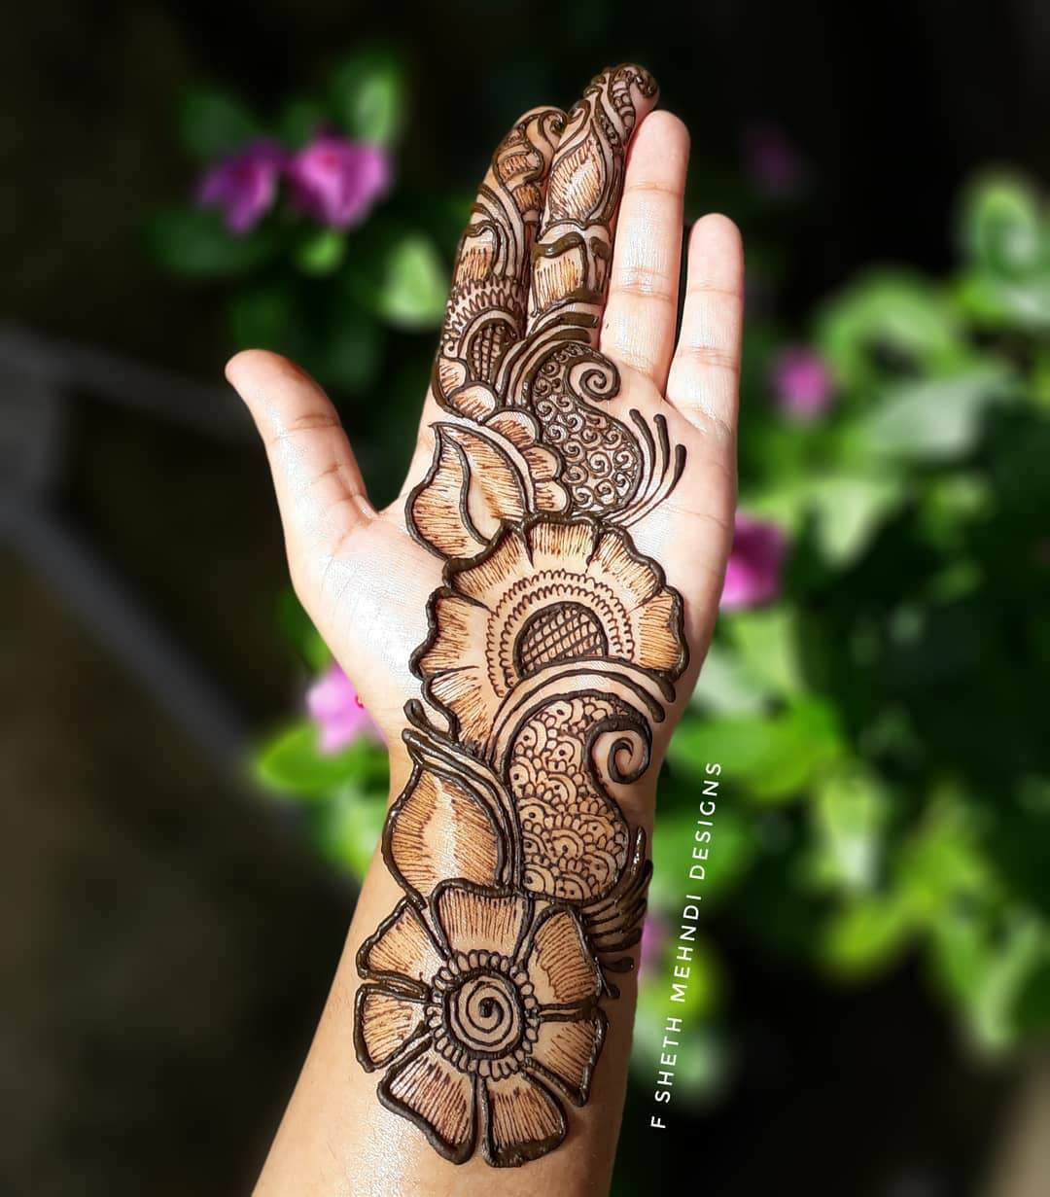  Reference photo-real 1 goregouslyflawed.com  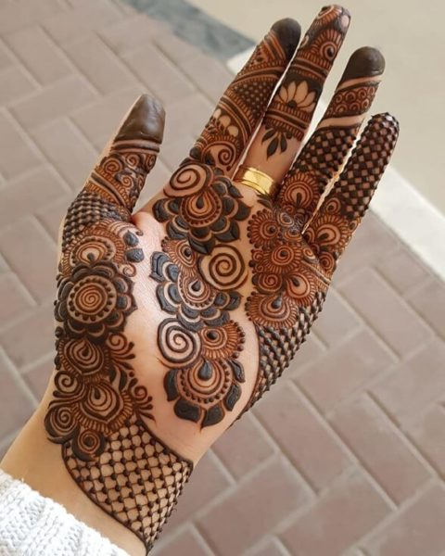  Reference photo-real 2 stylesatlife.com  Vocab:  Mehndi- form of body decoration through paste made of henna  Henna-plant that is ground up to make paste for Mehndi  Organic forms- refers to the curvilinear and free flowing forms  (contrast to geometric/rigid forms)  Teacher Example:  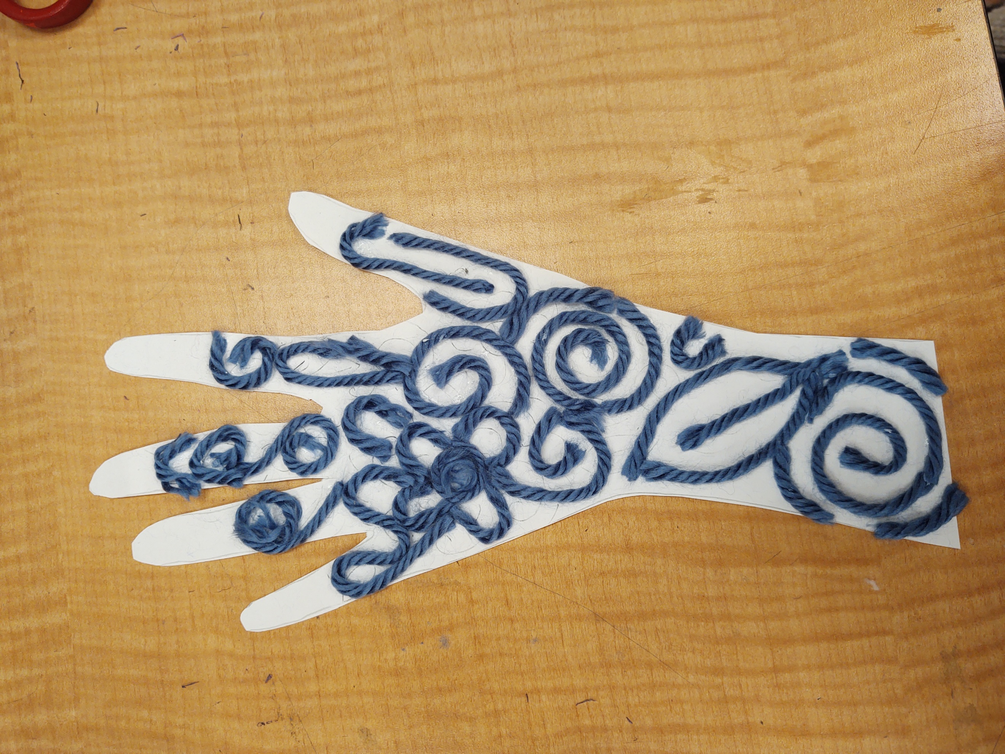

 | SLO #1 | SLO #2 | SLO #3
Students will . . . | …create a pattern designed with acknowledgment to Arabic Mehndi characteristics. | …take care with materials and exhibit good craftmanship. | …participate in peer review and reflect on their own work and others’.
Standard:  Creating, Presenting, Responding, Connecting | VA8.CR.1.a. | VA8.CR.1.b. | VA8.RE.2.a
Studio Habit: | Envision | Develop Craft | Reflect

Teacher instructions:
Introduction to topic/project: | The teacher will welcome students into class and gather attention.  The teacher will then talk to students about how we use art and decoration at celebrations, such as weddings-flowers, arch,tables/ bdayparties-balloons, streamers.  Also, they will talk about how at parties or celebrations people like to dress up.  They will end the discussion by talking about Mehndi as a way of physical decoration for celebrations in many cultures and has different variations depending on the culture. Mehndi is the art of body decoration through henna. Henna is a plant that is ground to a powder and turned to a paste. This paste is applied to the skin in skillful designs that leave a temporary stain.  The teacher then introduces that we will be trying our hand at Arabic Mehndi and display the real hands in reference material.  They will explain that Arabic Mehndi usually consists of floral, nature inspired designs and patterns (flowers, leaves, vines, curvy organic shapes).  The teacher will then leave the teacher example displayed on the screen.
Step by step instructions: | The teacher will instruct students to use a pencil to trace their hand and wrist onto construction paper and then draw their design inside (they will do it along with verbal instruction). They will remind the students to make the design open because the yarn is bigger than your pencil line. They then instruct that once the pattern is drawn the students can glue strings of yarn onto the lines. They remind them that it is easier to place a line of glue down and then place strings of yarn on top of it. The teacher will tell the students they can use multiple colors of yarn or keep the color uniform.  The teacher will tell the students that they may get their materials and begin working.  If the students finish, the teacher will tell them to put their pieces on the drying rack. The teacher will allow them to get a chromebook and research other cultures’ use of Mehndi.  Day 2:  All students will get their works. The teacher will instruct them to get some scissors and cut out their hands.  When everyone has completed their project, the students will take turns sharing their work with other students to self-reflect and receive feedback. The teach will instruct at the beginning that each student should say something they like, something they would change, and make one comment on another student.
Closure/wrap up | Day 1:  The teacher will instruct the students that it is time to clean up. The students will take their pieces and put it on the drying rack. Then, the students will put yarn back, put scraps in scrap box, and put up glue/pencil/eraser.  Day 2:  The students will turn in their projects into designated boxes and put scissors back up.

Assessment Measures
 | SLO #1 | SLO #2 | SLO #3
Students will . . . | …create a pattern designed with acknowledgment to Arabic Mehndi characteristics. | …take care with materials and exhibit good craftmanship. | …participate in peer review and reflect on their own work and others’.
Verification: | Visual Check | Visual Check | Check off on check list for each student that they mentioned something they like, something they would change, and that the student commented on at least one other student.
`

