Art Lesson Plan: Fourth: Modern Hieroglyphics
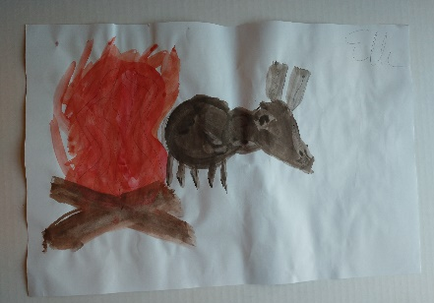
Lesson Title: Modern Hieroglyphics
Teacher(s): Ms. Madison Pritchard
Medium: Mixed Media
Grade Level: Fourth
Time Needed: 45 minutes, one class period
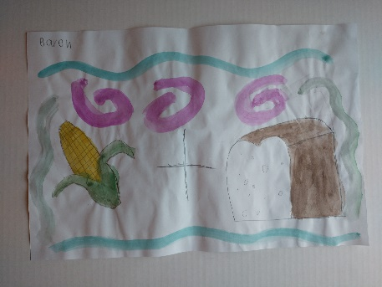
Materials and Resources:
- Pencil
- Paper
- Tempera paint
- Water cup
- Brush
- Permanent marker

Objectives of Goals: (SWBAT)
The student will create a work of art by communicating a word or object by using emojis.
The student will draw emojis based off of a reference sheet of emojis they can use.
The student will use tempera paint to put color into their piece.
The student will share their work and interact with others work by having a class discussion of what the pieces are
supposed to communicate.

Content Connections
(Highlight One) Math Music Social Studies/History Science Language Arts/Reading

This lesson connects with social studies because it incorporates hieroglyphics into the lesson, which is something they have learned about in their history class.

State Visual Arts Standards:
VA4.CR.1 Engage in the creative process to generate and visualize ideas by using subject matter and symbols to
communicate meaning.
a. Utilize multiple approaches to plan works of art incorporating imaginative ideas, universal themes, and symbolic images.
VA4.RE.1 Use a variety of approaches for art criticism and to critique personal works of art and the artwork of others to enhance visual literacy.
a. Interpret and evaluate works of art through thoughtful discussion and speculation about the mood, theme, and intentions of those who created a work of art.
Teacher Preparation:
- Powerpoint for introduction
- Water cups and paint on tables
- Emoji reference slide in powerpoint
Art History or Cultural Connections: Kids will incorporate their knowledge of hieroglyphics into a modern interpretation using emojis as symbols for communicating.

Elements of Art:
Shape: Basic shapes will be used to make up the different emojis. Students will explore replicating shape.
Color: Color will be used to make the drawings look like the emojis they represent.

Principles of Design:
Variety: Each student will have variety in their work because they are to use two different emojis for the project.

Vocabulary:
Hieroglyphics: Egyptian symbols used to communicate
Symbols: visuals that represent things and can be used to communicate
Creative Expression:

 | The teacher will... | The student will...
Anticipatory Set | Introduction  (5 minutes) | - Welcome into class, ask if they like to use emojis  - “how do we know what the emoji means?”  - “They are kind of like symbols.. like Egyptian Hieroglyphics.”  - Explain how when symbols are paired together it can mean something, and that is how the Hieroglyphics work for the Egyptians.  - Show examples in powerpoint, have them guess what it means.  - Introduce that they will be using two emojis to express something to the viewer. BUT they can’t tell their friends and classmates… because when they finish we will share some of our pieces and see if we can guess what it means. | - Come in and sit down in front of the board.  - Listen and pay attention to teacher.  - Raise hand to answer question when teacher asks.
Demonstration | Directed Drawing |  (2 minutes) | - Show them that there is a reference sheet in the powerpoint on the board with emojis on it for them to look at while drawing.  - Write their name and what the emojis mean on the back of their page. Then, they can draw the emoji. When they are drawn in pencil, they can outline it with a marker and paint them.  - Assign helpers to pass out paper, instruct them to get pencil and brush then start working. | - Pay attention to how to make the emoji piece.  - Wait to get paper, then go get brush and pencil.  - Sit down and then go to work.
Independent Practice  (30 minutes) | - Walk and observe progress.  - Give advice or prompts as needed | - Write their name and what the emoji will say on the back of paper.  - Draw emojis from reference sheet.  - Paint the emojis.
Clean-up  (5 minutes) | - Ask students to clean tables and put away supplies  - Have them line up at the door to go. | - Put away supplies.  - Line up at the door in a well-behaved manner.

Assessment Criteria (Related back to Instructional Objectives):

 | Excellent | Satisfactory | Unsatisfactory
Craftsmanship/ Signature | Student’s pieces are clean and not messy. Care was put into the piece to not have stray marks. Name is on paper with the word they are representing. | Student’s artwork is fairly clean, maybe a few stray marks or crinkles. Name is on paper with word they are representing. | Student’s artwork is full of stray marks and shapes are messy. Paint applied messily. No care in craftmanship. Name is missing.
Required content | Student’s artwork has two emojis used to express a word or thing. Makes sense. Emojis colored with paint and outlined with marker. | Student’s artwork includes two emojis that are used to express a word or thing. May or may not be the best emoji selection for making sense to viewer. Emojis are colored with paint, outlined in marker. | Student’s artwork is missing an emoji or what it is supposed to mean. May not make sense at all; doesn’t express what it should. Paint may have been used, but student didn’t complete coloring. Marker outline not present.
Elements and Principles Treatment | Student created the shape of the emojis correctly. Colors are appropriate for the emojis. | Student created shapes that are similar to what they are meant to represent . Colors are accurate. | Student created shapes that poorly represent the emojis. The colors are not appropriate for the emojis.

Aesthetic Question to Ask: What shapes are the emojis made of? What colors should we use for ____ emoji?

Alternative Project: Students will be asked to illustrate something by using symbols.

Modifications or Adaptions (this could also be termed differentiation): Students may finish the project at home, at recess, or at the end of the next class. If they struggle with motor skills to paint, they may cut out the emojis and place them on their sheet or color with different medium.

Teacher Reflection

The kids were super excited about this lesson! They thankfully got the concept of expressing something with the two emojis; some even asked if they could do more (maybe another lesson like that one day). They were excited about creating the piece. Only a few seemed to have a hard time drawing the emoji. A few wanted someone else to draw it for them, which they are used to because sometimes my mentor teacher will “help” them by doing it for them. Personally, I don’t want to draw or mark on my kids art. I tried to coach them through finding shapes and drawing the symbols on my own sheet of paper and have them follow along on their own. They had a good time guessing the meanings at the end of class as a group too. I think it went over well and plan to do it again in the future. I think tying it to hieroglyphics could be better executed. I would revisit that introduction and connection a bit to stress the symbols and hieroglyphics next time.

